On 19 January 2023, an EU symposium on 'Multifunctional forestry as a guarantor for biodiversity' was held in Berlin as part of the International Green Week (20-29 January 2023).

The German Forestry Council (DFWR) organized the symposium, chaired by Georg Schrimbeck, with the participation of PEFC.

Invited to participate in the discussion were: Sven-Erik Hammar President of the European Forest Owners Association (CEPF), Minister Maria Patek from the Austrian Federal Ministry of Agriculture, Forestry, Regions and Water Management, Prof. Tomasz Zawiła-Niedźwiecki from the Polish Forestry Society, also representing the KNLiTD of the Polish Academy of Sciences, Kai Lintunen from the Finnish Forestry Association, Maja Drča from the PEFC office to the EU and Rudolf Rosenstatter from the Austrian Forestry Association

Summarising the speakers' presentations, a spokesperson for the DFWR stated that Minister Maria Patek stressed that the effects of the Green Deal did not take into account the positive role of sustainable forestry and that we had received a large number of regulations in a very short time. Sven-Erik Hammar signaled that the principle of subsidiarity must be considered throughout the European Union and therefore against the background of different national conditions. He positively emphasized the strong cohesion of the EU, which has become apparent in recent months. Prof. Tomasz Zawiła-Niedźwiecki (presenting, inter alia, the opinion of the KNLiTD PAN and the results of the work of the NSZZ "Solidarność" KZNOŚiL Expert Team) was critical of the "Green Deal's" ignoring of the positive aspects of sustainable forestry and pointed to the possible negative effects of introducing some of the solutions proposed by the EU in both natural and economic terms. From the point of view of forest-rich Finland, Kai Lintunen highlighted the potential for using wood to transform towards a climate-neutral economy, for example in the construction sector. Maja Drča, on the other hand, talked about the functioning of the recognized certification system for sustainable wood use and presented PEFC's efforts to have its role and potential recognized by the Commission in the context of the planned EU forest certification scheme.

Photo: DFWR

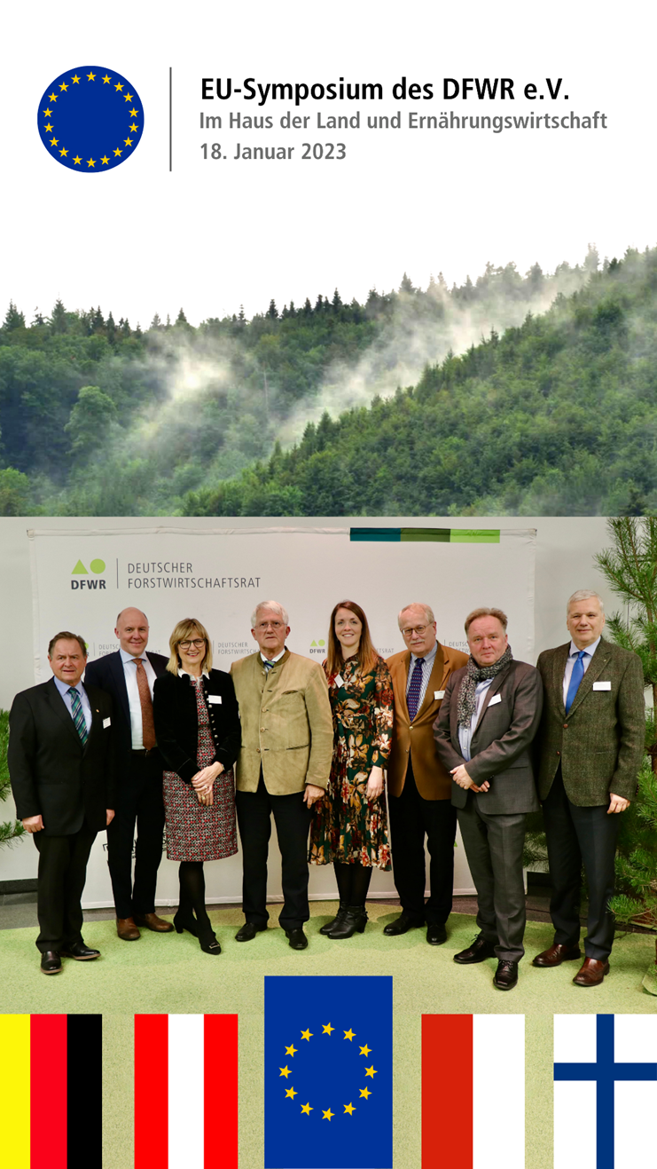

Debaters (from left): Rudolf Rosenstatter, Sven-Erik Hammar, min. Maria Patek, Georg Schrimbeck, Maja Drča, Axel Heider, Kai Lintunen, Tomasz Zawiła-Niedźwiecki.